Nexelus IPC Configuration

esm_logo.jpg

Nexelus USA  
New York, NEW YORK (NY)  
646-558-1950 ext.128

**2/23/2024**

# Document Information

The following table shows the details for document creation, review, approval, and effective date.

| **Category** | **Information** |
| --- | --- |
| Work Product: | IPC Configurations |
| Project Name: | Nexelus |
| Function Name: | IPC Configuration |
| Version: | 0.1 |
| Status: | Draft |
| Author(s): | Tauseef Shahzad |
| Reviewer(s): | Asim Jameel |
| Approver(s): | Imran Rahman |
| Control Status: | CONTROLLED, PROTECTED |
| Disclaimer: | This document contains confidential information. Do not distribute this document without prior approval from Nexelus. |

# Revision History

The following table is used for revision details of this document.

| **Author(s)** | **Date** | **Version** | **Description of Change** |
| --- | --- | --- | --- |
| Tauseef Shahzad | 2/23/2024 | 0.1 | Initial Draft |
|  |  |  |  |
|  |  |  |  |
|  |  |  |  |

# Table of Contents

Contents

[Document Information ii](#_Toc159583664)

[Revision History iii](#_Toc159583665)

[Table of Contents i](#_Toc159583666)

[Scope 1](#_Toc159583667)

[IPC Configurations 2](#_Toc159583668)

[Add new Ad Tool in IPC 3](#_Toc159583669)

[Define Ad Tool 3](#_Toc159583670)

[Define Entities for Ad Tool API 3](#_Toc159583671)

[Define Services against each Entity 4](#_Toc159583672)

[Define Operations against Ad Tool Services 4](#_Toc159583673)

[Define Elements against Ad Tool Service Operations 4](#_Toc159583674)

[Configure Ad Tools for Consumers 6](#_Toc159583675)

[Step 1: Define Consumer 6](#_Toc159583676)

[Define Consumer Account 6](#_Toc159583677)

[Define Ad Tool Access 7](#_Toc159583678)

[Ad Tool API Access 7](#_Toc159583679)

[Default values Ad Tools 8](#_Toc159583680)

[Define Account User 8](#_Toc159583681)

[Link Account User with Ad Tool 9](#_Toc159583682)

[Google Ads 10](#_Toc159583683)

[Create Account for Google Ads 11](#_Toc159583684)

[Create Manager Account 11](#_Toc159583685)

[Create Google Ads accounts 11](#_Toc159583686)

[Administering an existing Google Ads account 12](#_Toc159583687)

[Accept link 12](#_Toc159583688)

[Authorize Adwords and Invoice API 14](#_Toc159583689)

[Authorizing AdWords API 14](#_Toc159583690)

[Authorize invoice API 17](#_Toc159583691)

[Configure Google Ads in Nexelus 20](#_Toc159583692)

[Prerequisite: 20](#_Toc159583693)

[Whitelisting a MCC 20](#_Toc159583694)

[Required Information from Client 20](#_Toc159583695)

[Double Click Manager 21](#_Toc159583696)

[Create DCM Account 22](#_Toc159583697)

[Add a Nexelus User to DCM 22](#_Toc159583698)

[Needed Permissions 23](#_Toc159583699)

[DCM Sites 25](#_Toc159583700)

[Configure New DCM Client: 27](#_Toc159583701)

[Configure DCM in Nexelus 35](#_Toc159583702)

[Required Information from Client 35](#_Toc159583703)

[DV360 36](#_Toc159583704)

[Create DV360 Account 37](#_Toc159583705)

[Configure Google API Console Project 37](#_Toc159583706)

[OAuth 2.0 Scope Information 38](#_Toc159583707)

[Configure DV360 in Nexelus 39](#_Toc159583708)

[Required Information from Client 39](#_Toc159583709)

[Twitter Advertising 40](#_Toc159583710)

[Create Account for Twitter Advertising. 41](#_Toc159583711)

[Create a Project 41](#_Toc159583712)

[Creating or Connecting an App for your Project 41](#_Toc159583713)

[Configure Twitter advertising in Nexelus 43](#_Toc159583714)

[Required Information from Client 43](#_Toc159583715)

[Facebook Advertising 44](#_Toc159583716)

[Create Facebook Advertising Account 45](#_Toc159583717)

[Configure Facebook Advertising in Nexelus 51](#_Toc159583718)

[Required Information from Client 51](#_Toc159583719)

[IPC 52](#_Toc159583720)

[Nexelus: 52](#_Toc159583721)

[Delivery Pull Utility: 52](#_Toc159583722)

[The Trade Desk 53](#_Toc159583723)

[Create TradeDesk Account 54](#_Toc159583724)

[Configure The Trade Desk in Nexelus 55](#_Toc159583725)

[Required Information from Client 55](#_Toc159583726)

[Configure Trade Desk in IPC 55](#_Toc159583727)

[LinkedIn Advertising 57](#_Toc159583728)

[Create LinkedIn Ads Account 58](#_Toc159583729)

[Configure LinkedIn Ads in Nexelus 59](#_Toc159583730)

[Required Information from Client 59](#_Toc159583731)

[Microsoft Advertising 60](#_Toc159583732)

[Create Account for Microsoft Advertising 61](#_Toc159583733)

[Step 1: Visit the Microsoft Advertising Website 61](#_Toc159583734)

[Step 2: Sign Up with Your Microsoft Account 61](#_Toc159583735)

[Step 3: Fill Out the Account Details 61](#_Toc159583736)

[Step 4: Set Up Billing Information 61](#_Toc159583737)

[Step 5: Complete the Account Creation Process 61](#_Toc159583738)

[Configure Microsoft advertising in Nexelus 62](#_Toc159583739)

[Required Information from Client 62](#_Toc159583740)

[Configure Microsoft advertising in Nexelus 62](#_Toc159583741)

[Step 1:Provide access to Nexelus 62](#_Toc159583742)

[Step 2: Get a Developer Token 62](#_Toc159583743)

[Sizmek 63](#_Toc159583744)

[Create Sizmek Account 64](#_Toc159583745)

[Configure Sizmek in Nexelus 65](#_Toc159583746)

[Required Information from Client 65](#_Toc159583747)

[Configure Sizmek in Nexelus 65](#_Toc159583748)

# Scope

The scope of this document is to provide instructions for creating accounts on Nexelus supported Ad Servers as well as configuration and integration of these accounts in Nexelus Application. Nexelus currently support following Ad Servers:

* [Google Ads](#_Google_Ads)
* [Double Click Manager](#_Double_Click_Manager)
* [DV360](#_DV360)
* [Twitter Ads](#_Twitter_Advertising)
* [Facebook Ads](#_Facebook_Advertising)
* [The Trade Desk](#_The_Trade_Desk)
* [LinkedIn Ads](#_LinkedIn_Advertising)
* [Microsoft Ads](#_Microsoft_Advertising)
* [Sizmek](#_Sizmek)

# IPC Configurations

IPC is configured in IPC\_82 Database.

## Add new Ad Tool in IPC

### Define Ad Tool

All Ad Tools/Ad Services for which Nexelus API’s have been created, are defined in this table.

**PDIM\_AD\_TOOL**

|  |  |  |  |  |
| --- | --- | --- | --- | --- |
| **Field** | **Type** | **NN** | **Length** | **Description** |
| ad\_tool\_id | int | no | 4 |  |
| orig\_name | nvarchar | no | 256 |  |
| orig\_version | nvarchar | no | 100 |  |
| ipc\_name | nvarchar | no | 256 |  |
| ipc\_description | nvarchar | no | 2048 |  |
| ad\_tool\_category | int | no | 4 |  |
| is\_active | tinyint | no | 1 |  |
| ipc\_connector\_dll\_name | nvarchar | no | 256 |  |
| ipc\_connector\_dll\_description | nvarchar | no | 4096 |  |
| ipc\_connector\_dll\_is\_active | tinyint | no | 1 |  |
| ipc\_connector\_dll\_version | nvarchar | no | 256 |  |
| ipc\_connector\_dll\_release\_date | datetime | no | 8 |  |
| create\_id | nvarchar | no | 100 |  |
| create\_date | datetime | no | 8 |  |
| modify\_id | nvarchar | no | 100 |  |
| modify\_date | datetime | no | 8 |  |

### Define Entities for Ad Tool API

This table is used to specify Entity List and service against each Ad Tool API

**pdi\_ad\_tool\_ipc\_entity**

|  |  |  |  |  |
| --- | --- | --- | --- | --- |
| **Field** | **Type** | **NN** | **Length** | **Description** |
| ad\_tool\_id | int | no | 4 |  |
| entity\_id | int | no | 4 |  |
| global\_entity\_id | int | no | 4 |  |
| ad\_tool\_entity\_name | nvarchar | no | 256 |  |
| entity\_category\_code | nvarchar | no | 100 |  |
| is\_active | tinyint | no | 1 |  |
| create\_id | nvarchar | no | 100 |  |
| create\_date | datetime | no | 8 |  |
| modify\_id | nvarchar | no | 100 |  |
| modify\_date | datetime | no | 8 |  |

### Define Services against each Entity

All Entity Services are defined in this table

**pdi\_ad\_Tool\_entity\_category**

|  |  |  |  |  |
| --- | --- | --- | --- | --- |
| **Field** | **Type** | **NN** | **Length** | **Description** |
| ad\_tool\_id | int | no | 4 |  |
| entity\_category\_code | nvarchar | no | 100 |  |
| entity\_category\_desc | nvarchar | no | 256 |  |
| entity\_category\_type\_id | int | no | 4 |  |
| create\_id | nvarchar | no | 100 |  |
| create\_date | datetime | no | 8 |  |
| modify\_id | nvarchar | no | 100 |  |
| modify\_date | datetime | no | 8 |  |

### Define Operations against Ad Tool Services

This table lists operations against each service for Ad Tools.

**pdi\_ad\_tool\_ipc\_entity\_alter\_operation**

|  |  |  |  |  |
| --- | --- | --- | --- | --- |
| **Field** | **Type** | **NN** | **Length** | **Description** |
| ad\_tool\_id | int | no | 4 |  |
| entity\_id | int | no | 4 |  |
| alter\_operation\_id | int | no | 4 |  |
| alter\_operation\_name | nvarchar | no | 256 |  |
| order\_id | int | no | 4 |  |
| comments | nvarchar | no | 4000 |  |
| is\_active | tinyint | no | 1 |  |
| create\_id | nvarchar | no | 100 |  |
| create\_date | datetime | no | 8 |  |
| modify\_id | nvarchar | no | 100 |  |
| modify\_date | datetime | no | 8 |  |

### Define Elements against Ad Tool Service Operations

This table contains elements against each operation for a service of an Ad Tool

**pdi\_ad\_tool\_ipc\_entity\_element**

|  |  |  |  |  |
| --- | --- | --- | --- | --- |
| **Field** | **Type** | **NN** | **Length** | **Description** |
| ad\_tool\_id | int | no | 4 |  |
| entity\_id | int | no | 4 |  |
| element\_id | int | no | 4 |  |
| global\_entity\_id | int | no | 4 |  |
| global\_element\_id | int | no | 4 |  |
| order\_id | int | no | 4 |  |
| ad\_tool\_element\_name | nvarchar | no | 512 |  |
| element\_description | nvarchar | no | 2048 |  |

## Configure Ad Tools for Consumers

### Step 1: Define Consumer

Nexelus Clients using IPC are defined in following table.

**PDM\_CONSUMER**

|  |  |  |  |  |
| --- | --- | --- | --- | --- |
| **Field** | **Type** | **NN** | **Length** | **Description** |
| consumer\_id | int | no | 4 |  |
| name | nvarchar | no | 256 |  |
| consumer\_type\_id | tinyint | no | 1 |  |
| cat\_code\_01\_id | int | no | 4 |  |
| cat\_code\_02\_id | int | no | 4 |  |
| cat\_code\_03\_id | int | no | 4 |  |
| cat\_code\_04\_id | int | no | 4 |  |
| cat\_code\_05\_id | int | no | 4 |  |
| cat\_code\_06\_id | int | no | 4 |  |
| cat\_code\_07\_id | int | no | 4 |  |
| cat\_code\_08\_id | int | no | 4 |  |
| cat\_code\_09\_id | int | no | 4 |  |
| cat\_code\_10\_id | int | no | 4 |  |
| create\_id | nvarchar | no | 100 |  |
| create\_date | datetime | no | 8 |  |
| modify\_id | nvarchar | no | 100 |  |
| modify\_date | datetime | no | 8 |  |

### Define Consumer Account

The account IDs against each client are defined in this table. These account IDs are used to reference Ad Tool configurations for clients. One client may have more than one Consumer account.

**PDM\_CONSUMER\_ACCOUNT**

|  |  |  |  |  |
| --- | --- | --- | --- | --- |
| **Field** | **Type** | **NN** | **Length** | **Description** |
| account\_id | char | no | 128 |  |
| consumer\_id | int | no | 4 |  |
| eff\_date | datetime | no | 8 |  |
| exp\_date | datetime | no | 8 |  |
| payment\_method\_id | int | no | 4 |  |
| payment\_terms\_id | int | no | 4 |  |
| billing\_address\_seq\_id | int | no | 4 |  |
| create\_id | nvarchar | no | 100 |  |
| create\_date | datetime | no | 8 |  |
| modify\_id | nvarchar | no | 100 |  |
| modify\_date | datetime | no | 8 |  |

### Define Ad Tool Access

Attributes used for Ad Tool Api access are defined in following table. Each attribute is given an api\_access\_property\_id.

**PDIM\_AD\_TOOL\_API\_ACCESS**

|  |  |  |  |  |
| --- | --- | --- | --- | --- |
| **Field** | **Type** | **NN** | **Length** | **Description** |
| ad\_tool\_id | int | No | 4 |  |
| api\_access\_property\_id | int | no | 4 |  |
| display\_order | int | no | 4 |  |
| label | nvarchar | no | 256 |  |
| help\_description | nvarchar | no | 4096 |  |
| is\_required | tinyint | no | 1 |  |
| create\_id | nvarchar | no | 100 |  |
| create\_date | datetime | no | 8 |  |
| modify\_id | nvarchar | no | 100 |  |
| modify\_date | datetime | no | 8 |  |

### Ad Tool API Access

This table contains parameter values for Ad Tools against each account

**PDM\_ACCOUNT\_AD\_TOOL\_API\_ACCESS**

|  |  |  |  |  |
| --- | --- | --- | --- | --- |
| **Field** | **Type** | **NN** | **Length** | **Description** |
| ad\_tool\_id | int | no | 4 |  |
| api\_access\_property\_id | int | no | 4 |  |
| display\_order | int | no | 4 |  |
| label | nvarchar | no | 256 |  |
| help\_description | nvarchar | no | 4096 |  |
| is\_required | tinyint | no | 1 |  |
| create\_id | nvarchar | no | 100 |  |
| create\_date | datetime | no | 8 |  |
| modify\_id | nvarchar | no | 100 |  |
| modify\_date | datetime | no | 8 |  |

### Default values Ad Tools

Default Ad Tool Attributes shared across all consumer accounts.

**PDIM\_AD\_TOOL\_PROPERTY**

|  |  |  |  |  |
| --- | --- | --- | --- | --- |
| **Field** | **Type** | **NN** | **Length** | **Description** |
| ad\_tool\_id | int | no | 4 |  |
| property\_id | int | no | 4 |  |
| property\_data\_type | int | no | 4 |  |
| property\_label | nvarchar | no | 510 |  |
| property\_value | nvarchar | no | 4096 |  |
| is\_required | tinyint | no | 1 |  |
| is\_editable | tinyint | no | 1 |  |
| combo\_ref\_entity\_name | nvarchar | no | 256 |  |
| create\_id | nvarchar | no | 100 |  |
| create\_date | datetime | no | 8 |  |
| modify\_id | nvarchar | no | 100 |  |
| modify\_date | datetime | no | 8 |  |

### Define Account User

User Accounts against consumer account is created. This account user and password is for accessing IPC Account.

**PDM\_ACCOUNT\_USER**

|  |  |  |  |  |
| --- | --- | --- | --- | --- |
| **Field** | **Type** | **NN** | **Length** | **Description** |
| account\_id | char | no | 128 |  |
| user\_id | nvarchar | no | 256 |  |
| user\_name | nvarchar | no | 512 |  |
| password | nvarchar | no | 256 |  |
| is\_active | tinyint | no | 1 |  |
| dev\_token | nvarchar | no | 256 |  |
| create\_id | nvarchar | no | 100 |  |
| create\_date | datetime | no | 8 |  |
| modify\_id | nvarchar | no | 100 |  |
| modify\_date | datetime | no | 8 |  |

### Link Account User with Ad Tool

Ad Tools are mapped with account ID

**PDM\_ACCOUNT\_USER\_AD\_TOOL**

|  |  |  |  |  |
| --- | --- | --- | --- | --- |
| **Field** | **Type** | **NN** | **Length** | **Description** |
| account\_id | char | no | 128 |  |
| ad\_tool\_id | int | no | 4 |  |
| seq\_id | int | no | 4 |  |
| user\_id | nvarchar | no | 256 |  |
| create\_id | nvarchar | no | 100 |  |
| create\_date | datetime | no | 8 |  |
| modify\_id | nvarchar | no | 100 |  |
| modify\_date | datetime | no | 8 |  |

# Google Ads

Google Ads is Google's online advertising program. Through Google Ads, you can create online ads to reach people exactly when they're interested in the products and services that you offer.

## Create Account for Google Ads

### Create Manager Account

You can use a Google Ads manager account to manage multiple Google Ads sub-accounts in one place.

You can't create campaigns or advertise products directly with a manager account, but you can use it to create campaigns on behalf of a sub-account that you manage.

1. Sign in to the Google account you want to use as a manager account.
2. Visit the manager account page, then click Create a manager account. (<https://ads.google.com/home/tools/manager-accounts/>)
3. Name your manager account. This is the name that your merchants see as their manager in the Access & Security tab of the Google Ads UI.
4. Choose how to use the account. If you need to manage sub-accounts on behalf of other advertisers, choose "Manage other people's accounts".
5. Select your country and time zone.
6. The time zone you select is used for reporting and billing, and you can't change it later. We recommend that you choose the time zone your business is based in.
7. Choose a permanent currency for your account billing.
8. We recommend that you choose the currency you use for business. Sub-accounts are billed in their own currencies.
9. Click SUBMIT.

### Create Google Ads accounts

You need an individual Google Ads account to create campaigns and advertise products. This page describes how to use a manager account to create individual Google Ads sub-accounts.

1. Sign in to Google Ads with your manager account credentials and navigate to the Accounts section.
2. Click the + button, then click + Create new account.
3. Choose a country and time zone to use for reports and billing.
4. You can't change these later. We recommend choosing the country and time zone you do business in.
5. Choose a permanent currency for your account billing.
6. You can't change this later. We recommend choosing the currency you do business in.
7. Click SAVE AND CONTINUE, then enter your billing information and click SUBMIT.

### Administering an existing Google Ads account

When you link an existing Google Ads account to a manager account, the Google Ads account and its history don't change. The original advertisers don't lose access to billing or sign-in.

You can also link another manager account to your manager account, which lets you manage and view data for all of the Google Ads accounts under that manager account.

A manager account can only have one manager account directly above it.

An individual Google Ads account can be linked to no more than five manager accounts, and your manager account structure can be no more than six levels deep.

1. Find the Google Ads customer ID for the account you want to manage in the top right corner of the Google Ads account.
2. Sign in to your manager account on the Google Ads UI.
3. Click the Accounts tab.
4. Click the Performance tab.
5. Click the + plus button.
6. Click + Link existing account.
7. Once you've reviewed the terms, enter the Google Ads Customer ID. To link multiple accounts at once, enter one Customer ID per line.
8. Click SEND REQUEST. The Google Ads account receives an account notification and email that invites them to link to your manager account.

A pending notification appears in your manager account's Pending link requests. Once the invited account accepts your invitation, you receive an email confirmation and the accounts are linked. See Link accounts for more information.

### Accept link

Any user with administrative access on the invited account or on a linked manager account can accept your invitation with the following steps:

* Click the gear icon.
* Choose Account settings from the drop-down menu.
* Select Account access from the side navigation, then click Accept invitation.
* Manager accounts can be assigned the following levels of access:
* Administrative
* Standard
* Read only
* Email only

## Authorize Adwords and Invoice API

The setup involves following steps:

1. Authorize Adwords API
2. Authorize Invoice API

### Authorizing AdWords API

1. Go to console <https://console.developers.google.com> and log in using the clients google credentials.
2. Create a project if already not created.
3. Create credentials using “OAuth Client ID”

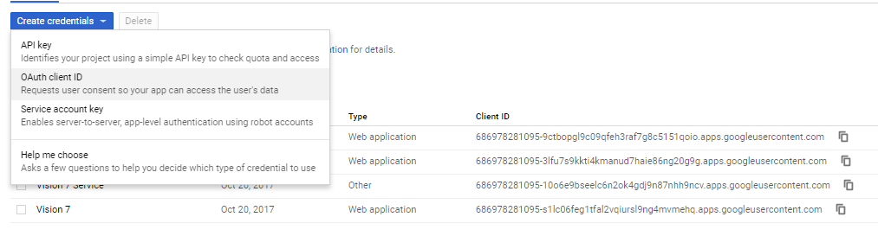

1. Following Client ID and Client Secret were generated:
   * 1. Client ID
     2. Client Secret
2. After getting the client id and client secret, Goto <https://developers.google.com/oauthplayground>
3. On the right-hand side click the settings icon and use the following information:

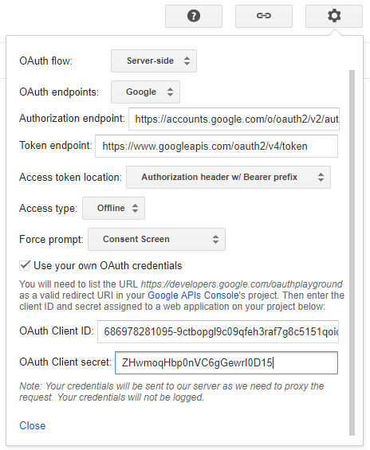

1. On the left-hand side enter the scope “https://www.googleapis.com/auth/adwords” and press “Authorize APIs”.

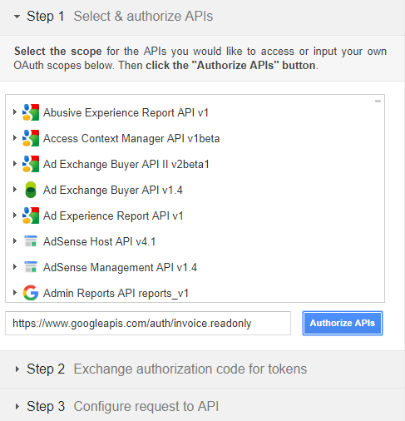

1. This will redirect to sign in to account again, go ahead and do that.
2. After successful authorization you will be provided with the “Authorization Code” which is then used to exchange for Tokens

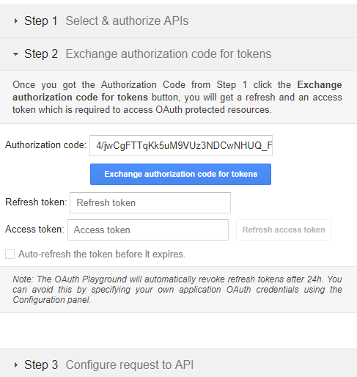

1. Press “Exchange authorization code for tokens” for getting refresh token and access token.
2. Access token is not used as it is generated every time during authentication process but take note of the refresh token.

### Authorize invoice API

1. Go to console <https://console.developers.google.com> and log in using the client’s google credentials.
2. Create a project if already not created.
3. Create credentials using “OAuth Client ID”



1. Following Client ID and Client Secret were generated:
2. Client ID
3. Client Secret
4. After getting the client id and client secret, Goto <https://developers.google.com/oauthplayground>
5. On the right-hand side click the settings icon and use the following information:



1. On the left-hand side enter the scope “<https://www.googleapis.com/auth/invoice.readonly>” and press “Authorize APIs”.



1. This will redirect to sign into account again, go ahead and do that.
2. After successful authorization you will be provided with the “Authorization Code” which is then used to exchange for Tokens



1. Press “Exchange authorization code for tokens” for getting refresh token and access token.
2. Access token is not used as it is generated every time during authentication process but take note of the refresh token.

## Configure Google Ads in Nexelus

### Prerequisite:

We need to firm-up on below two points:

1. Confirmation, if the new client is part of Main MCC or if it has a separate MCC of it’s own
2. Confirmation, if the new client is already whitelisted for API integration by Google. If not please ask your rep to whitelist.

### Whitelisting a MCC

1- Get a developer token from Google Ads which will allow us to integrate. If you already have a developer token for a client’s MCC then simply provide us with Token and password.

To get a new developer token, please fill this form (<https://support.google.com/adspolicy/contact/new_token_application>) as detailed on sign-up page (<https://developers.google.com/google-ads/api/docs/start>) .

Check with your Google rep or Google API team if your MCC is whitelisted for Budget Order API (for budget order service API, i.e. ability to create Budget Order from Nexelus)

Note that the 360i Master MCC is already whitelisted for Budget Order creation.

Use attached Design document when signing up for developer token or whitelisting MCC.

2- Access level: We will need “Basic” access for the API.

3- Once we have the access please allow “Permissible” usage for ‘Ad creation / management’ and ‘Reporting’. Application link can be found here (<https://developers.google.com/google-ads/api/docs/start#permissible_use>).

### Required Information from Client

1. Master account ID
2. Client ID
3. Client Secret
4. Refresh Token (JSON File)

# Double Click Manager

DoubleClick Campaign Manager is at the core of our DoubleClick Digital Marketing platform. It re-imagines how marketers and agencies manage the entire scope of their digital marketing efforts - from planning and executing, to measuring and optimizing their campaigns.

## Create DCM Account

Our login [Nexapi@nexelus.net](mailto:API360i@nexelus.net) has API read only access to the Test account/network. We need following access

* 1. Full Read access
  2. Write access to create/edit Campaigns, placement/packages and Ads.

DCM: If the new client is using DCM, we need the ‘write’ access to DCM live accounts. See slides 4-8

Steps:

1. Add a Nexelus User [Nexapi@nexelus.net](mailto:API360i@nexelus.net) to DCM with required access & permissions
2. Send Nexelus list of DCM Sites

### Add a Nexelus User to DCM

* Click on “Admin” menu and select User profiles

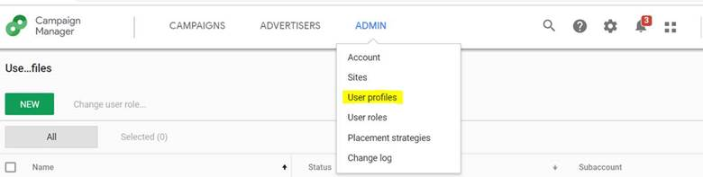

* Click on “New” button; this opens a window for new profile

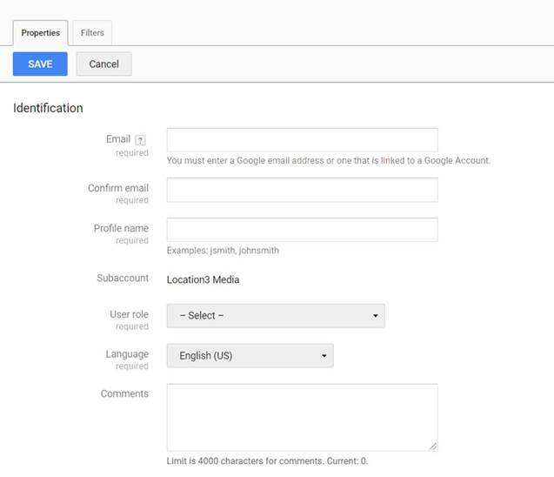

* Enter Information in newly opened window
  + - Enter [Nexapi@nexelus.net](mailto:API360i@nexelus.net) in email and confirm email field
    - Enter profile name. You can use any name, however it’s preferred to use “Nexelus\_Account” where account is DCM account number
    - Select appropriate role
      * *You can use the default role “Agency Media Planner”. Or create a new role; see next slide for Permissions needed.*
    - Select “Filter” tab, where you can filter data which this profile can access, you can select “Allow all” for all categories if you want to give this profile access to all data under this account
* Press “Save” button to save profile

### Needed Permissions

If choosing to create a new User Role for Nexelus, please ensure they are provided the permissions indicated in the screenshots by red boxes

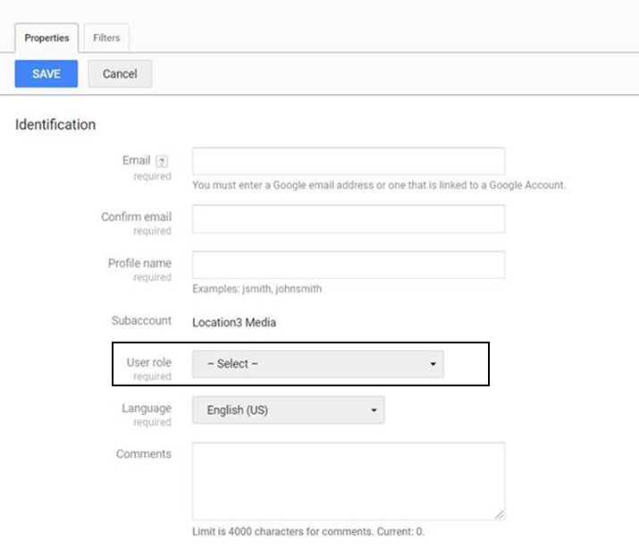

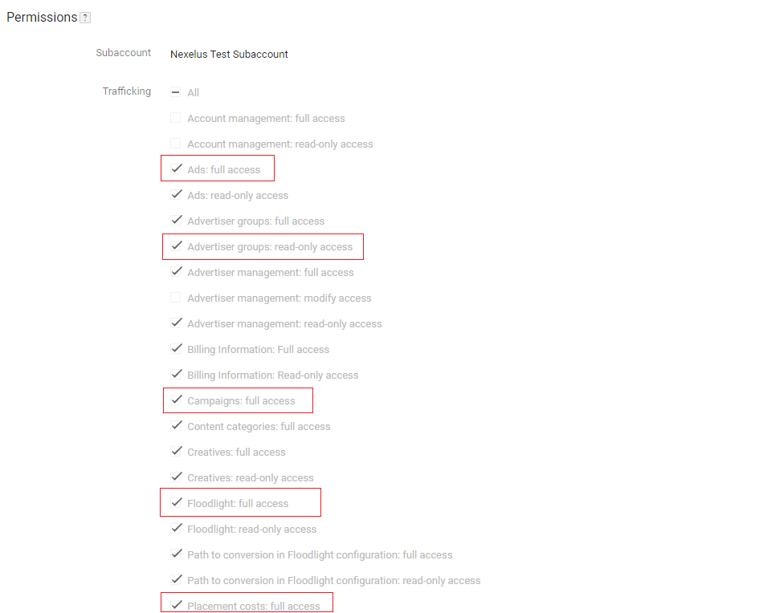

### DCM Sites

Please provide Nexelus with a list of DCM Sites (and their IDs) from the Network which company may be expect to use in the future.

We will set these up in Nexelus.

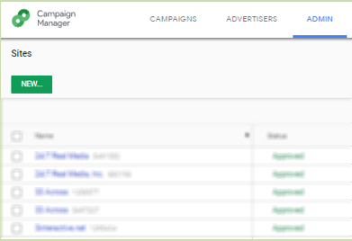

## Configure New DCM Client:

* Goto <https://console.developers.google.com> and sign in using the clients credentials
* If no project is created, then create a new project e.g. “tmk-nexelus-net”

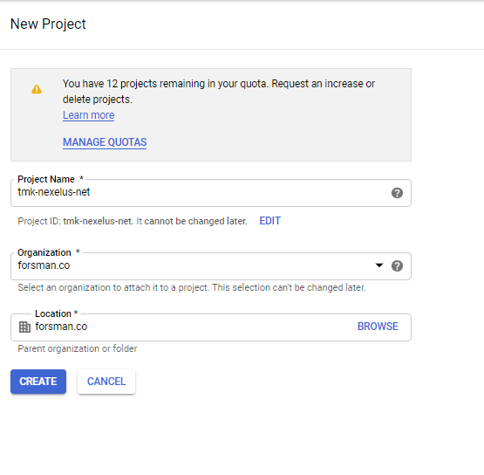

* Select any organization/location from the dropdown, normally it will be auto selected.
* Goto Libraries

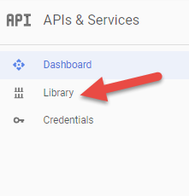

* Search for “dfa” and activate the API. It should look like below once enabled.

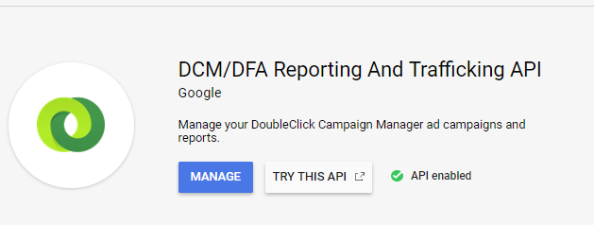

* After enabling the API, we need to create credentials for IPC to use the API
* Goto credentials and create new OAuth Client ID

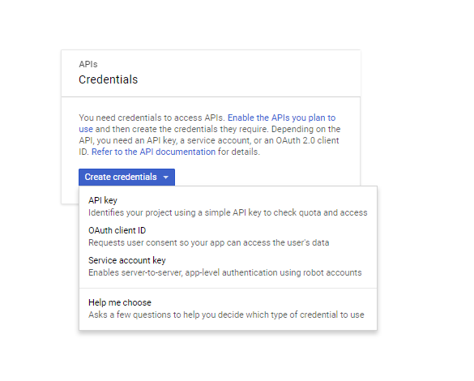

* When creating the credentials first time it will ask to create a product first, go ahead and create that.

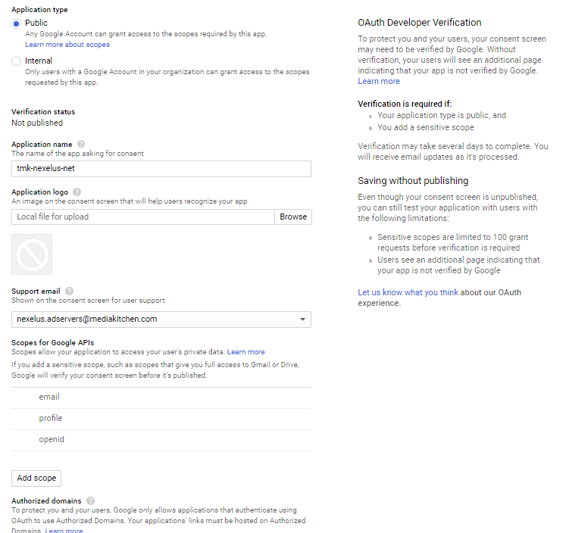

* You can give any application name but preferably the same name as project name.
* After creating product, go ahead and create the service key

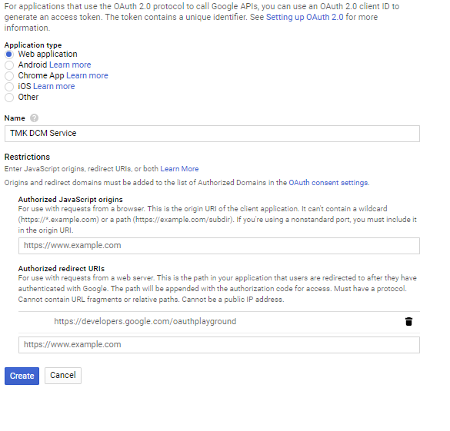

* Make sure to create as “Web Application”.
* Give name
* Make sure to add “https://developers.google.com/oauthplayground” as an Authorized redirect URIs
* Once created console will provide you with the client id and client secret

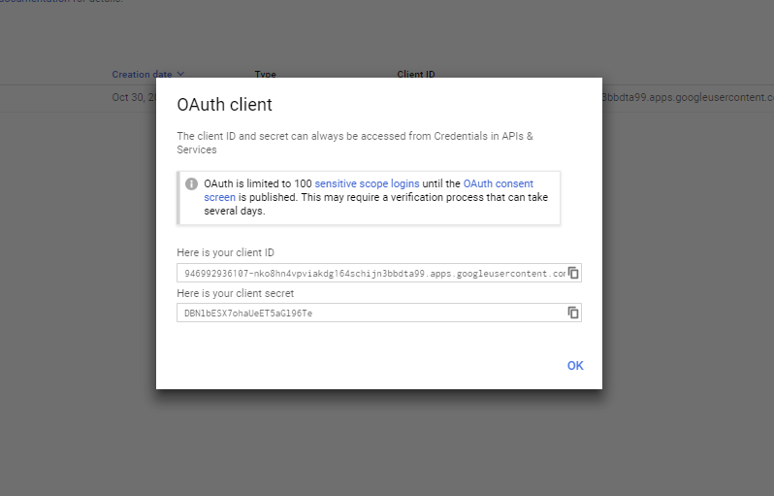

* Make note of these two things as we would need this in configuring IPC and fetching OAuth 2.0 refresh token and access key.
* Now goto <https://developers.google.com/oauthplayground/>
* In the settings menu on the right hand side, make sure the following are selected as:

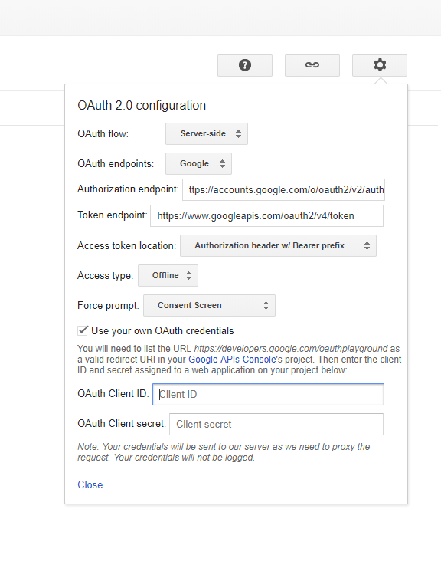

* Provide the client id and client secret from the earlier step.
* In right hand side select 2 APIs to authorize and press “Authorize APIs”

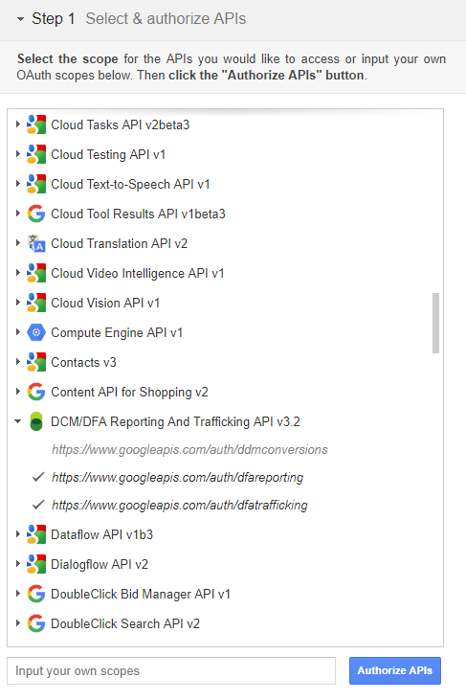

* Google will redirect to re-login for permissions, go ahead and do that using the google credentials.
* Once done you will be redirected back to oath playground and authorization code will be provided

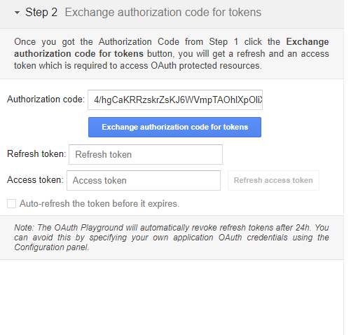

* Go ahead and press “Exchange authorization code for tokens”.
* Once done, you will be provided with refresh token and access token.

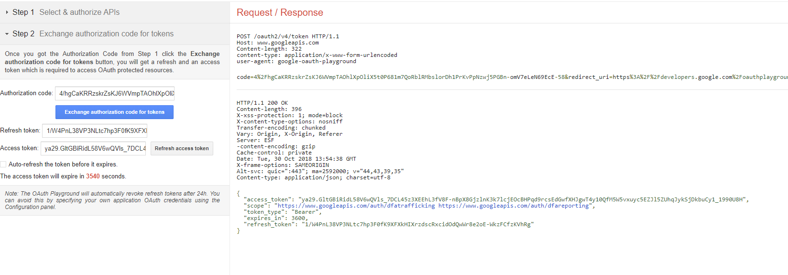

* Make sure you note these or the JSON on the right side. We will need these for configuring IPC as well.

## Configure DCM in Nexelus

* Now go ahead and connect to the server where IPC is deployed and make your way to the IPC root directory. (Please note that there might be different versions of IPC deployed, make sure you are in the correct directory by confirming where client’s Nexelus IPC is pointed to.)
* If the Nexelus’s IPC pointing is changed in future, then the next step would need to be repeated as well.
* Inside the IPC root folder create a folder with client name
* Inside this folder create a file with name “Google.Apis.Auth.OAuth2.Responses.TokenResponse-{project-name-from-above-steps}”. The extensions will be “TokenResponse-{project-name-from-above-steps}”
* Open the file in notepad.
* From the refresh token step. Copy the JSON created and paste it in the file.
* Please note the path of this file. We would need to use it in the scripts.
* After this run the scripts provided. Make sure to add the information required in the declared variables.

### Required Information from Client

1. Network ID
2. Profile ID
3. Network Name
4. Client ID
5. Client Secret
6. Refresh Token (JSON File)

# DV360

Google Display & Video 360 enables marketers to manage their reservation, programmatic, and programmatic guaranteed campaigns across display, video, TV, audio, and other channels, all in one place. It is organized around five integrated modules that work together: Campaigns, Audiences, Creatives, Inventory, and Insights.

## Create DV360 Account

The following general process applies to all application types:

1. When you create your application, you register it using the Google API Console ([<https://console.cloud.google.com/>](https://console.cloud.google.com/)). Google then provides information you'll need later, such as a client ID and a client secret.
2. Activate the Display & Video 360 API in the Google API Console. (If the API isn't listed in the API Console, then skip this step.)
3. When your application needs access to user data, it asks Google for a particular scope of access.
4. Google displays a consent screen to the user, asking them to authorize your application to request some of their data.
5. If the user approves, then Google gives your application a short-lived access token.
6. Your application requests user data, attaching the access token to the request.
7. If Google determines that your request and the token are valid, it returns the requested data.

### Configure Google API Console Project

The following instructions guide you through the process of creating an OAuth 2.0 client ID to use with the installed application flow.

1. Follow the steps to configure a Google API Console project ([[https://developers.google.com/display-video/api/guides/getting-started/overview#create\_project](https://developers.google.com/display-video/api/guides/getting-started/overview)](https://developers.google.com/display-video/api/guides/getting-started/overview#create_project)).
2. Open the Credentials page in the API Console ([<https://console.cloud.google.com/apis/credentials>](https://console.cloud.google.com/apis/credentials))
3. Click Create credentials > OAuth client ID.
4. Select the most applicable application type when prompted.
5. Enter any additional required information.

If this is your first time creating a client ID, besides being able to select your application type, you can configure your consent screen by clicking the Configure consent screen button. You will not get a prompt to configure your consent screen again after you do it the first time, although this information can be updated at any time.

1. Click Create.

When done, you'll be presented with an OAuth 2.0 client ID and client secret, which you can download in JSON format and save for later use.

### OAuth 2.0 Scope Information

Here's the OAuth 2.0 scope information for the Display & Video 360 API:

* <https://www.googleapis.com/auth/display-video>

Read/write access.

* <https://www.googleapis.com/auth/display-video-user-management>

Read/write access for user's service. Only available for service account users.

To request access using OAuth 2.0, your application needs the scope information, as well as information that Google supplies when you register your application (such as the client ID and the client secret).

## Configure DV360 in Nexelus

### Required Information from Client

1. Network ID
2. Network name

# Twitter Advertising

Twitter may not be the first social network that pops to mind when thinking about your social advertising strategy. But consider that Twitter ads can reach a potential audience of 486 million users. Ad formats range from ultra-simple to highly sophisticated. And there’s no minimum spend.

## Create Account for Twitter Advertising.

Login to twitter developer account on <https://developer.twitter.com>

Click on Developer Portal link in top right corner.



### Create a Project

Projects allow you to organize your work based on how you intend to use the Twitter API, so you can effectively manage your access to the API and monitor your usage

To create a Project, click on “New Project” in your [dashboard](https://developer.twitter.com/en/portal/dashboard) or the [Projects & Apps](https://developer.twitter.com/en/portal/projects-and-apps) page within the developer portal. You’ll only be able to see this option if you haven’t already created a Project. You will be prompted to create a Project name, description, and use case. You will also be asked to create a new App or connect an existing standalone App.

### Creating or Connecting an App for your Project

Accessing the Twitter Ads API endpoints requires a set of authentication credentials, also known as keys and tokens, that you must pass with each request.

Each Project can contain an App, with which you can generate authentication credentials (keys and tokens).

If your Project doesn’t include an App, you can add one by clicking on the Project name in the dashboard. From there, you can create a new App. The App is where you can generate your authentication keys and tokens, including the **API Key** and **API Secret**, **Access Token** and **Access Token Secret**. You can add a maximum of 10 apps to your project.



From the left menu, under Projects & Apps, click on the project. It will display the Apps in that project.

Click on Keys and Token icon.

Generate two Consumer keys as API Key and API Secret and save somewhere

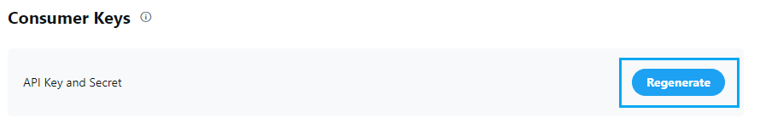

Generate two Authentication tokens as Access Token and Access Secret and save somewhere

Provide the generated 4 keys to Nexelus consultant.

Please note that you cannot regenerate these Keys once provided to Nexelus as it will create new credentials and invalidate the old ones. This means that any integrations that have been setup with prior credentials have to be updated.

## Configure Twitter advertising in Nexelus

### Required Information from Client

1. Account ID
2. API Consumer Key
3. Consumer Secret
4. Access Token
5. Access Token Secret

# Facebook Advertising

Facebook is where people connect, and in recent years more people have been using Facebook to connect in another way: buying and selling with each other. This activity started in Facebook Groups and has grown substantially. More than 450 million people visit buy and sell groups each month — from families in a local neighborhood to collectors around the world.

## Create Facebook Advertising Account

1. **Add Facebook NEXELUS App:**

To add the Nexelus App in Facebook. The Facebook Admin needs to follow the below steps:

In the Business Settings, click on Accounts >> Apps then click on Add button, in the drop-down menu click on “Request Access to an App”.

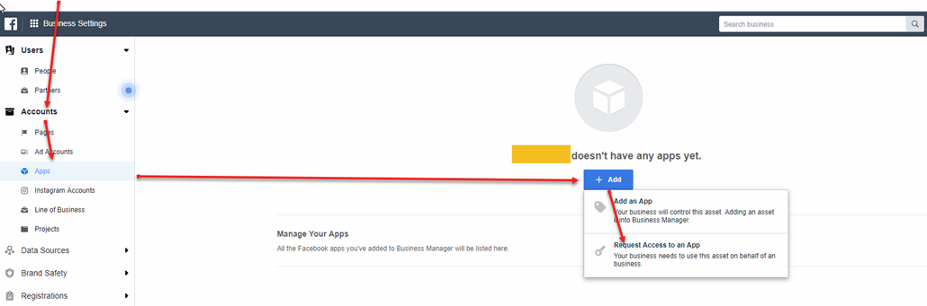

1. In the pop up fill out the field using Nexelus App ID 602632833545694. Once Nexelus approve the request you should see the app appear on the Apps screen.

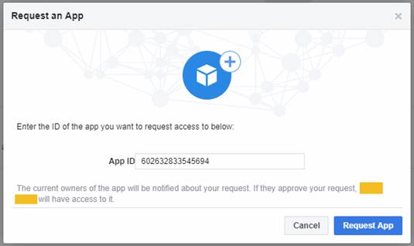

1. Once the permission is granted. You will need to create a system user.

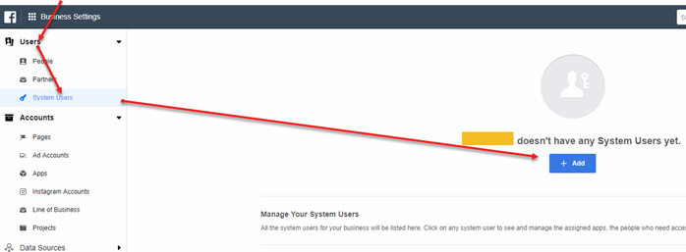

1. In the popup “Create System User”. Please name the user “Nexelus” and keep the system User Role to “Regular System User”.

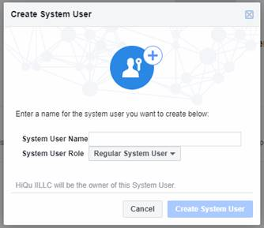

1. After the user is created. Please select the user and generate a token.

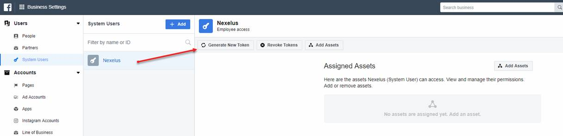

1. In the pop up, select the Nexelus app.

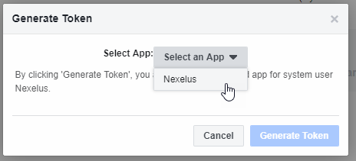

1. After the App is selected. Please check of the following settings and then click on “Generate Token”

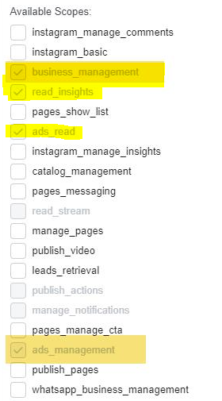

1. After the token is generated, please provide the “Access Token” to Nexelus.

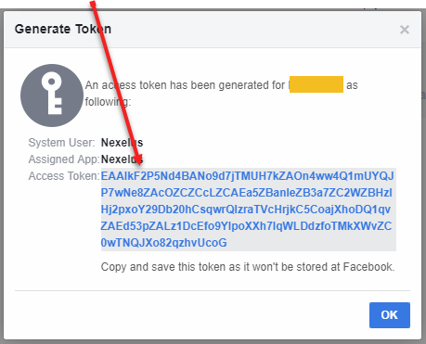

1. Please also provide your Ad Account ID that you would like Nexelus to pull delivery data from. This is located under Accounts >> Ad Accounts.

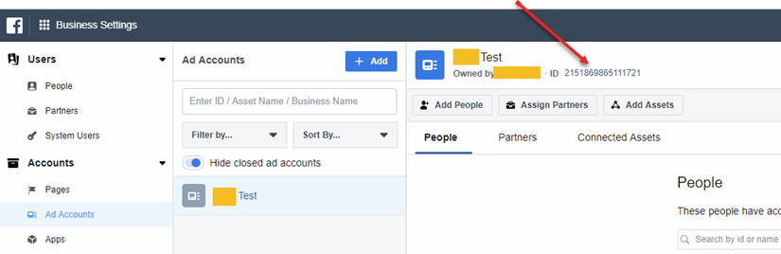

1. In the Ad Accounts, please add the System User “Nexelus” in the Ad Account and grant only view performance access.

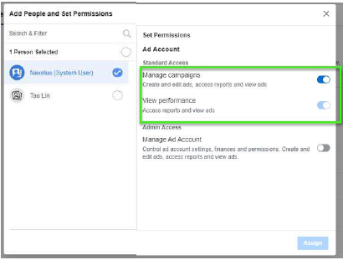

## Configure Facebook Advertising in Nexelus



### Required Information from Client

1. Facebook Refresh Token with Extended Time.

### IPC

* Find the SQL script from TFS: *$/eSMMain/Document Management/iPC Configurations/Facebook*
* Reset following information before executing the script
  + Access\_Tag
  + iPC\_Name
  + FB\_Token\_ID
    - Get Token from US Team.
  + Ad\_Tool\_Name
  + Consumer\_Name
  + Consumer\_Account – *If new consumer needs to be added*
  + User\_Account\_ID
  + User\_Account\_Name
* Run the SQL Script on iPC database to create iPC Account.
* SP “sp\_validate\_login\_attempt” provided at the end script will validate the account and it returns 0 as error\_code in case of success.

### Nexelus:

Currently Nexelus link Facebook campaign(s) through Ext. Reference field provided at IO Screen > IO Popup, so there is no need to configure anything at the moment, however this will be changed very soon, and document will be updated accordingly.

### Delivery Pull Utility:

Facebook delivery pull needs Facebook Ad Accounts to pull delivery against them, which needs to be listed on Utility side as below. *[Note: this needs to be changed to pick accounts from table, once we store ad accounts in db table]*

* COMPANY\_CODE
* ADTOOLS=Facebook
* DATE\_PERIOD=YESTERDAY
* START\_DATE="2019-07-01 00:00:00" END\_DATE="2019-07-01 23:59:59"
  + Dates are not applicable for date\_period = “Yesterday”
* DATE\_FORMAT="yyyy-MM-dd HH:mm:ss"
* FB\_ACCOUNT\_LIST="Comma separated ad accounts"

# The Trade Desk

The Trade Desk, Inc. is an American multinational technology company that specializes in real-time programmatic marketing automation technologies, products, and services, designed to personalize digital content delivery to users.

## Create TradeDesk Account

1. Create an account and verify your email address.

To create an account, you need to provide your name, email address, phone number, company name and address, and other information.

1. Choose the API features and custom solutions that meet your needs

This step typically requires close collaboration with your Account Manager and Technical Account Manager. Certain custom solutions might require additional paperwork and access permissions.

1. Sign all the contract and other required paperwork and receive your API credentials.

After your account is set up, you'll receive an activation email with your API credentials that allow you to access both the sandbox and production environments.

NOTE: Your API credentials do not provide access to the platform UI.

1. Use your API credentials to generate an authentication token ([<https://api.thetradedesk.com/v3/portal/api/doc/Authentication>](https://api.thetradedesk.com/v3/portal/api/doc/Authentication)) and start building your integrations.

Here's what you need to know about using the platform API:

To access the platform API, you must authenticate yourself.

Communication with the platform API is performed using JSON over HTTPS.

To test your integrations, use the sandbox environment at <https://apisb.thetradedesk.com/v3/>.

For more information, see Using The Trade Desk Platform API ([<https://api.thetradedesk.com/v3/portal/api/doc/ApiUsageGuidelines>](https://api.thetradedesk.com/v3/portal/api/doc/ApiUsageGuidelines)).

## Configure The Trade Desk in Nexelus

### Required Information from Client

1. User Name
2. Password
3. Domain

### Configure Trade Desk in IPC

1. Execure TTD script “new\_ttd\_client\_integration.sql” on IPC DB.
2. In Company -> IPC Integration tab add the new record using the “Access Tag” and rest of the information just created through scripts.
   * **AdTool** – TradeDesk
   * **Account ID** – 601
   * **User ID** – TradeDeskBilling
   * **Password** – password
   * **Access Tag** – “From the script”
   * **Ad Tool Category** – TradeDesk Billing API
     + If ad tool category is not shown in the drop down, then please check the company rule “**CompanyRules/Billing/IntegrationServices/AdToolBilling**” and make sure that “Search: TradeDesk” is selected.
   * Make sure the Ad Tool added is active for it to work.

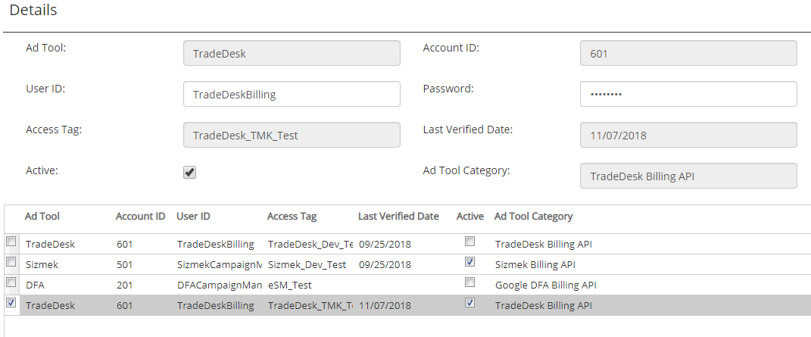

1. After this setup run the script “ttd\_nexelus\_setup.sql”.
2. There are company rules which defines which Trade Desk Field (partner id, advertiser id) will be mapped to which screen.
   * CompanyRules/Billing/IntegrationServices/Mapping/TradeDeskBilling/PartnerID
   * CompanyRules/Billing/IntegrationServices/Mapping/TradeDeskBilling/AdvertiserID
3. These rules must be set prior to be able to configure TTD partner/advertisers to Client Profile.

# LinkedIn Advertising

LinkedIn Ads campaigns can be used for job recruitment ads, service and product sales, lead generation, promoting content, increasing visibility, and reach for a new company location. LinkedIn offers many marketing solutions for companies to benefit from expanding their online reach.

## Create LinkedIn Ads Account

## Configure LinkedIn Ads in Nexelus

### Required Information from Client

# Microsoft Advertising

Microsoft Ads Manager is a powerful tool that businesses can use to create and manage pay-per-click advertising campaigns across the Microsoft Advertising Network. In this section, we will guide you through the process of setting up a Microsoft Ads Manager account, so that you can take advantage of this powerful advertising tool.

## Create Account for Microsoft Advertising

### Step 1: Visit the Microsoft Advertising Website

The first step to creating a Microsoft Ads Manager account is to visit the Microsoft Advertising website. You can access the site by typing “Microsoft Advertising” into a search engine or by visiting the URL directly.

<https://ads.microsoft.com/>

### Step 2: Sign Up with Your Microsoft Account

You can sign in with your existing credentials if you already have a Microsoft account. If you do not have a Microsoft account, you can create one for free.

### Step 3: Fill Out the Account Details

After you have signed in to your Microsoft account, you will be prompted to fill out your account details. This includes your business name and address and your website or landing page URL.

### Step 4: Set Up Billing Information

Next, you will need to set up your billing information. This includes providing a valid payment method, such as a credit card. You will also need to set a budget for your advertising campaign.

### Step 5: Complete the Account Creation Process

Finally, you will need to review your account details and accept the Microsoft Advertising terms and conditions. Once you have done this, you can click “Create Account” to complete the process.

## Configure Microsoft advertising in Nexelus

### Required Information from Client

1. Client ID
2. Client Secret
3. Developer Token
4. Refresh Token

### Configure Microsoft advertising in Nexelus

We need access to **Microsoft Ads** in order to pull delivery and create IOs.

### Step 1:Provide access to Nexelus

Please add Nexelus email address [Nexapi@nexelus.net](mailto:Nexapi@nexelus.net)

### Step 2: Get a Developer Token

To use Bing Ads APIs, you must have a developer token and valid user credentials.

Instructions to get Developer Token are given below:

1. Sign in with Super Admin credentials at the account tab in Microsoft Advertising Developer Portal ( <https://developers.ads.microsoft.com/Account>).
2. Choose the user that you want associated with the developer token. Typically, an application only needs one universal token regardless of how many users will be supported.
3. Click on the Request Token button.

The universal developer token can be used to authenticate with any Microsoft Advertising user credentials. You can use the same universal developer token whether your application will be used by one or multiple Microsoft Advertising users.

# Sizmek

Sizmek is an ad serving platform that allows data, media, and creative material (i.e. banners) to work together and be monitored for optimal performance across its entire online journey.

## Create Sizmek Account

[To be added later]

## Configure Sizmek in Nexelus

### Required Information from Client

1. User Name
2. Password
3. API Domain

### Configure Sizmek in Nexelus

1. First run the Sizmek script “new\_sizmek\_client\_integration\_ipc.sql” on IPC DB.
2. In Company -> IPC Integration tab add the new record using the “Access Tag” and rest of the information just created through scripts.
   * **AdTool** – Sizmek
   * **Account ID** – 501
   * **User ID** – SizmekCampaignManagement
   * **Password** – password
   * **Access Tag** – “From the script”
   * **Ad Tool Category** – Sizmek Billing API
     + If ad tool category is not shown in the drop down, then please check the company rule “**CompanyRules/Billing/IntegrationServices/AdToolBilling**” and make sure that “Ad Serving: Sizmek” is selected.
   * Make sure the Ad Tool added is active for it to work.

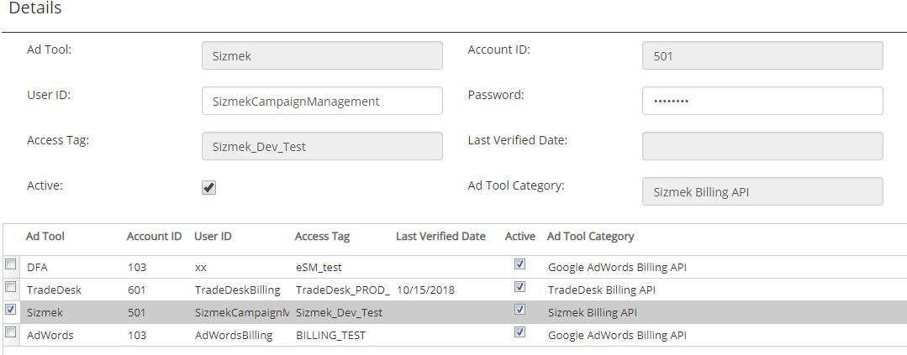

1. After this setup run the script “**sizmek\_nexelus\_setup.sql**”.